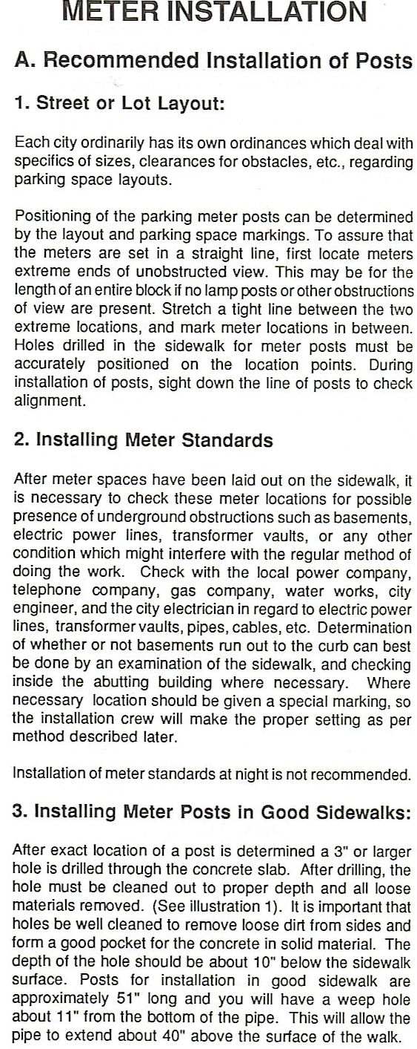 | 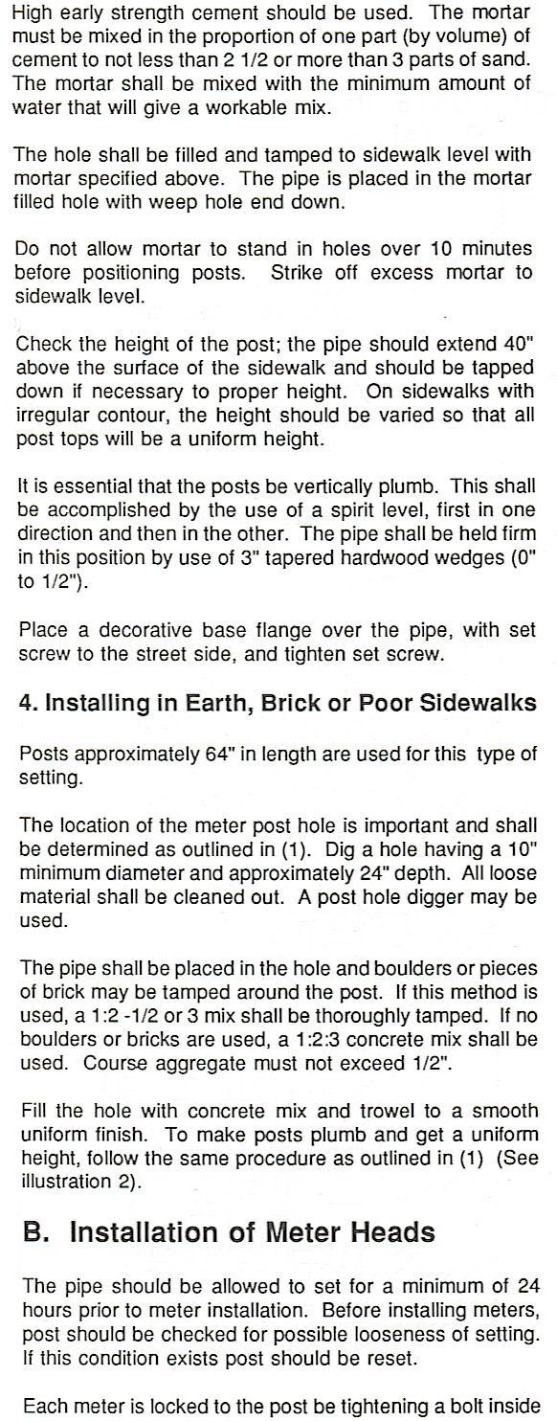

1
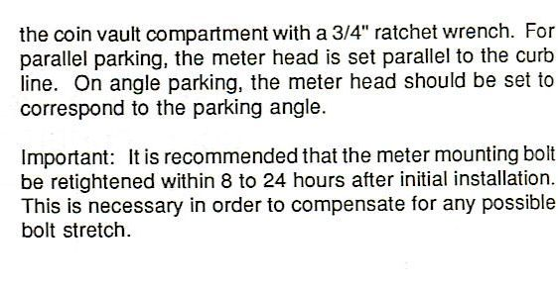

Pipe must ANSI Schedule 40 galvanized steel pipe, Standard 2” from ANSI pipe chart (which is actually 2.067” ID and 2.375” OD). Our meters and wedge mounting hardware will not fit into smaller ID pipe. Larger pipe will not fit into our Victorian sleeves and bases and will have too much room inside for our wedge mounting hardware. This has been an industry standard pipe size for parking meters for many years and fits all brands of single-space parking meters.

2
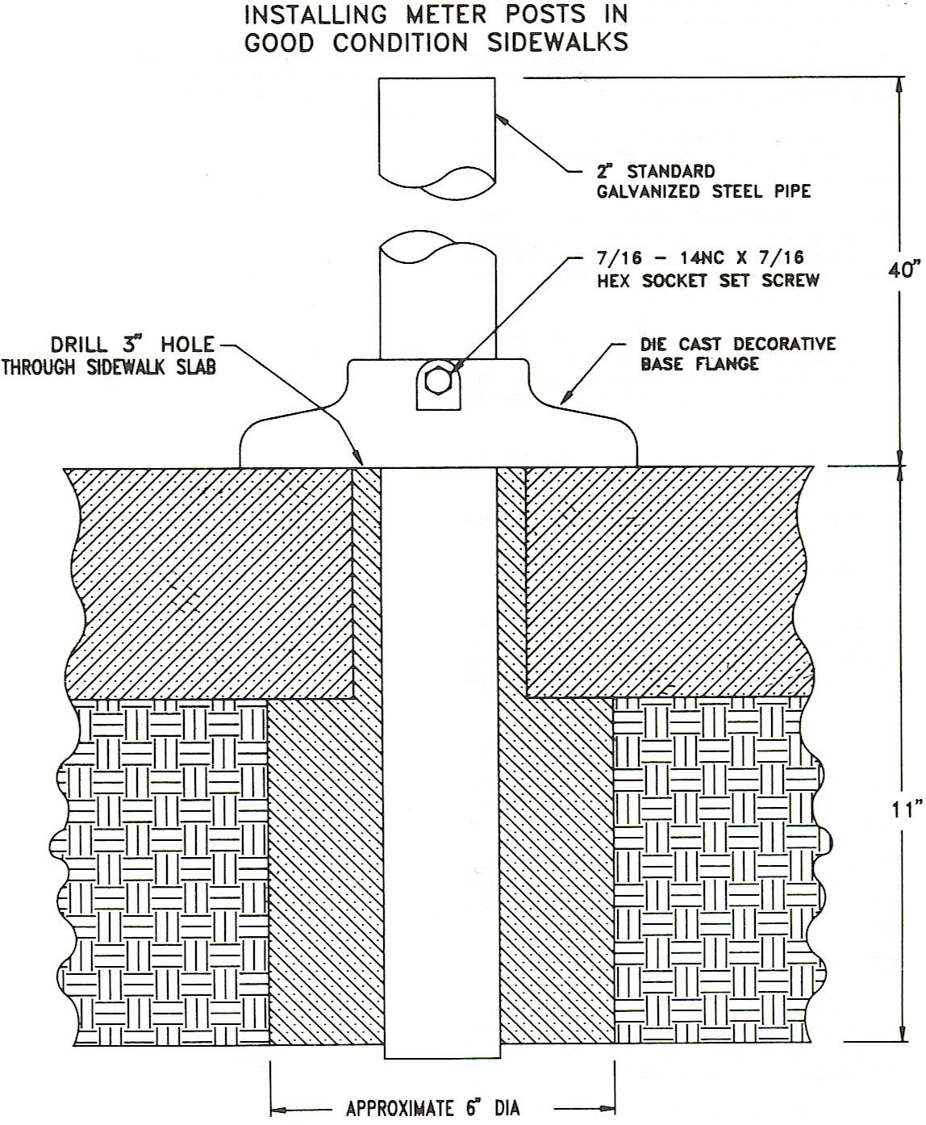
2” STD SCHEDULE 40 GALVANIZED STEEL PIPE (2.067” ID, 2.375” OD, ANSI)

3
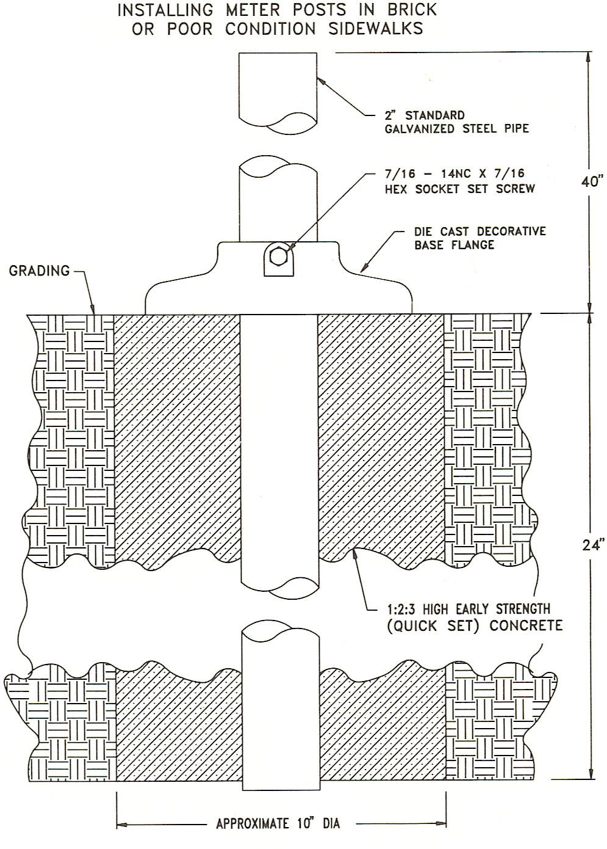
2” STD SCHEDULE 40 GALVANIZED STEEL PIPE (2.067” ID, 2.375” OD, ANSI)

4

